Treasure Hunter

* Jacket
  + Brown or olive/khaki green
  + Short sleeve
    - Rolled up sleeve?
    - Longer undershirt covering forearms?
* Hat
  + Indiana Jones style or classic Style
* Pants
  + Analogous or monochromatic to shirt
    - Similar looking colours can be broken up with a strong colour separating
    - Duller to draw attention to upper body
  + Fitted
* Build
  + Small
    - Chibi-inspired
* Backpack
  + Optional
  + Explorer’s Pack
    - Light brown
* Boots
  + Black or brown leather over pants
* Adding interest
  + Add Accessories
    - Whips, patches, etc.
    - Complementary colour on accessory
  + Add interesting feature
    - Ears, tail, ??

Not the design, just for annotation

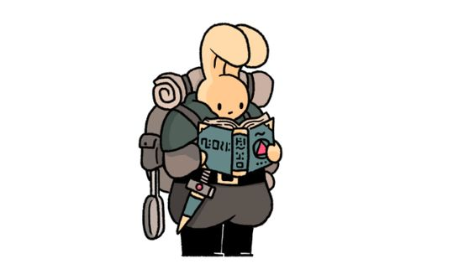

Grey pants to give colour by association

Belt breaks the green and grey

Explorer’s Backpack

The Green Colour

Hat

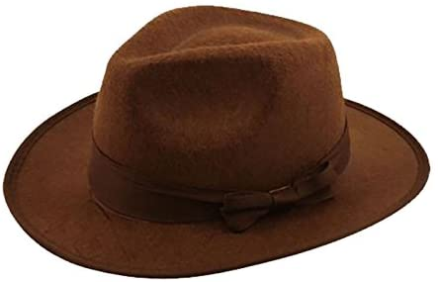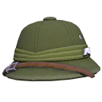Indiana Jones Classic